UDC 378.147.091.313:004

Roman P. Medvediev
Master of Specialty
015 "Professional Education (Computer Technology)"
Vinnytsia Mykhailo Kotsiubynskyi State Pedagogical University,
Vinnytsia, Ukraine
romadgan96@gmail.com
Liudmyla S. Shevchenko
Doctor of Pedagogical Sciences,
Assistant Professor
Department of Innovative and Information Technologies
Vinnytsia Mykhailo Kotsiubynskyi State Pedagogical University,
Vinnytsia, Ukraine
lysi4801@gmail.com
ORCID ID 0000-0003-4991-4949
Volodymyr O. Umanets
PhD of Pedagogical Sciences ,
Assistant Professor, Head of Information and Computing Center
Vinnytsia Mykhailo Kotsiubynskyi State Pedagogical University,
Vinnytsia, Ukraine
umkavin@gmail.com
ORCID ID orcid.org/0000-0002-7237-4955

ELECTRONIC EDUCATIONAL RESOURCES OF TEACHING OF THE BASIS OF DESKTOP PUBLISHING FOR THE FUTURE TEACHERS OF VOCATIONAL EDUCATION

Abstract. The article describes the experience of designing and using in the process of training future educators professional training of electronic educational resource for the study of computer layout foundations.
In the course of our research, we have found out the possibility of using electronic educational resources in the educational process of Higher education institutions to train future teachers of vocational education. In particular, we have developed an electronic educational resource «Basics of Computer Layout», in which, according to, the necessary training materials and author's methodological developments for learning the basics of computer layout in the Adobe InDesign CS5 software environment are structured.
The Word Press content management system (CMS), which has open source code and is distributed under the GNU GPL license, has become a popular medium for creating the described ESM.
The developed ESM contains a set of copyright educational and methodological materials, materials for monitoring the level of educational achievements, together they allow the future teachers of vocational training to form the theoretical knowledge and practical skills of the basics of computer layout in the Adobe InDesign CS5 software environment.
For the purposeful implementation of conceptual research ideas, the author developed a method for using a complex of electronic educational resources for teaching computer graphics to future bachelors of the specialty 015.10 «Professional education (computer technologies)». The method involves the provision of practical knowledge and skills to future bachelors of vocational education in order to form professional competencies in the Special Informatics discipline (module 3 Fundamentals of computer layout in the Adobe In Design CS5 program).
Keywords: e-learning resource; computer layout; Adobe InDesign CS5; WordArt; Learning Apps; My Test X; future educators of professional training.

1. INTRODUCTION
Problem statement. The current stage of the development of higher education of Ukraine is characterized by a special intensity and scale of transformations, caused in particular by the European integration and globalization processes, which require reloading of the system of higher education in the direction of informatization and optimization of the educational process. In this context, the problem of finding innovative methods, forms and means of learning is based on information and communication technologies (ICTs), which are going to create a new generation of teachers, to provide an increase of the quality of training of future specialists in the field of education, in particular, teachers of vocational training.
One of the ways of solving the problem of finding innovative methods, forms and means of training is the development and introduction of electronic educational resources (EER) in the educational process of higher education institutions (HEI).
Analysis of recent research and publications. Some experience in creating electronic educational resources is reflected in the works of V. Bykov, V. Gur, L. Zainutdinova, L. Kartashova, N. Olefirenko, A. Osina and others. The basis of the technology of designing electronic educational resources offered by these scientists is laid psychological and pedagogical requirements, models of content and mastering of educational material, modern concepts of information and education environment and the methodology of designing EER. In addition, the works of these scholars indicate that an important aspect of the EER's design process is the compliance of its structure with the requirements for the structure of electronic educational resources, as set forth in the "Regulations on Electronic Educational Resources" [1].
2. RESEARCH RESULTS
The development of information technologies (IT) and learning tools (R & D) on their basis began to develop in Ukraine in the 1970's, but today, in spite of all the efforts of both educators and scientists, IT is used insufficiently and inefficiently, the development of information and communication technologies has determined the emergence of a new form of education - e-learning, teaching using ICT.
The basis of electronic education is the electronic educational resources (EER), the concept EER in Ukraine became commonly used at the beginning of the XXI century. According to the order of the Ministry of Education and Science, Youth and Sports of Ukraine No. 1060 of 10/01/2012 "About Approval of the Regulation on Electronic Educational Resources" [1] its basic definition was fixed: "... educational, scientific, informational, reference materials and tools developed in electronic form and presented on media of any type or placed on computer networks reproduced by means of electronic digital means and necessary for the effective organization of the educational process, in the part concerning its filling educational materials ... ".
The main types of EER, as O. Spirin mentions [2, p. 81], include the following: an electronic document; e-edition; electronic analogue of the printed publication; electronic didactic demonstration materials; depository of electronic resources; computer test; electronic dictionary; electronic directory, etc. According to the functional feature of EER can be classified as: educational, methodological, educational, auxiliary, controlling.
Electronic educational resources from the technical point of view - a set of programs and data, from the point of view of the consumer - is the content, that is, a set of content elements representing objects, processes, abstractions, which are the subject of study. At the same time, effective EERs have a high degree of interactivity and multimedia saturation, and also have the ability to network distribution [3].
As N. Morseau and O. Glazunov mentioned [4, p. 42-43], the EER must meet the following requirements: compliance with the curriculum for which the EER has been developed; availability of appropriate methodological recommendations of the use of EER in the professional activity of the teacher / teacher; observance of the current sanitary, ergonomic, programmatic and technical requirements and norms to the EER; conformity with international technical standards (SCORM, Experience API, etc.); compliance with Ukrainian legislation. EER does not require duplication in paper form.
As O. Matviychuk-Judin wrote [5, p. 256], which developing the EER, arbitrary instrumental software, hardware and hardware may be used subject to the requirements for the creation and use of copyright and related rights objects regulated by the Law of Ukraine "On Copyright and Related Rights" and other legislative acts Of Ukraine.
According to the EER in accordance with the above-mentioned requirements, with the use of the software tools of the content management system (CMS) Word Press, which has open source and distributed under the GNU GPL license, an electronic educational resource for learning of desktop publishing was developed ( Fig.1).
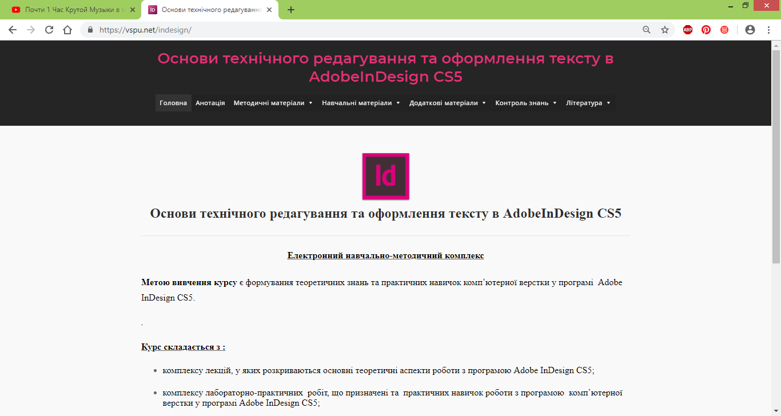

Fig. 1. Home page of the electronic educational resource "Basics of desktop publishing"

The developed EER contains a set of author's educational and methodological materials, materials for monitoring the level of educational achievements, which in aggregate allow the future teachers of professional training to develop theoretical knowledge and practical skills of the basics of computer layout in the software environment Adobe InDesign CS5.
In order to visualize the educational material, to ensure the interactivity of the educational process, to increase the interest of students in the study of the basics of computer layout, to deepen their knowledge and to realize the educational tasks of the discipline, we used the following services:
1. WordArt is a web service that allows you to create a cloud of words from text entered by the user or from a web page with the address. The cloud may have a different shape and color solution. Each word cloud is a hyperlink to search on Google. In our EOR, using the cloud of tags, a glossary of the main terms for each topic is implemented ( Fig. 2).
Fig. 1. The cloud of tags, a glossary of the main terms for each topic is implemented
2. Mind Meister - a service for creating mental maps (knowledge maps).
Mental maps are one of the ways to process information graphically and visually, the type of recording ideas and thoughts. The essence of building a mental map is that with the help of clear symbols, images, objects, associations, which the person thinks, clearly depict a coherent picture of knowledge about the subject of study, consideration. In the developed EER, mental maps are positioned as reference abstracts of key concepts of each topic (Fig. 3).

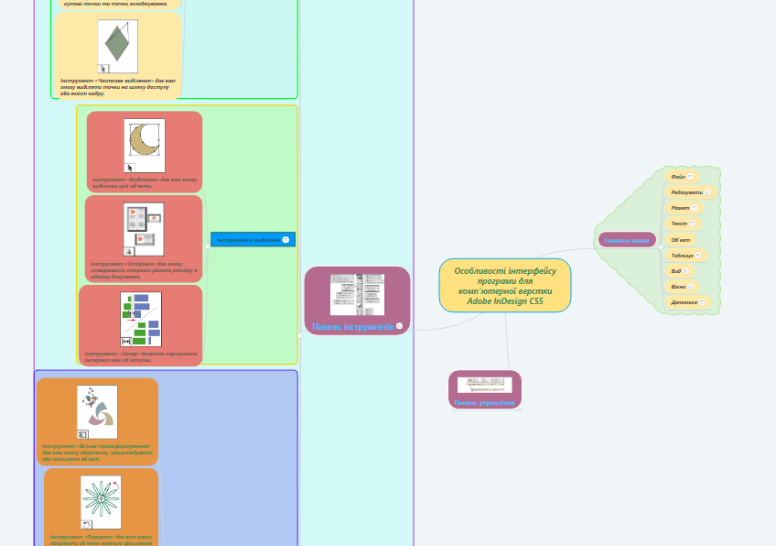
Fig. 3. A set of mental maps as a didactic material for lectures on the basics of computer layout
It is worth noting the positive aspects of the use of YouTube video hosting in the educational process, which allows the placement of educational videos with the ability to create a teacher of their own YouTube channel. In the structure of didactic materials developed by us EOR, an important place is occupied by a set of specially selected and structured video tutorials on the basics of work in the computer layout environment (Fig. 4).
Fig. 4. A set of video tutorials for presenting educational material

An important stage in the educational process is knowledge control. In order to test the acquisition of knowledge acquired by students, it is expedient to use the services for creating tests. Teachers who are users of a Google Account in this situation are comfortable to use the Google Forms service ( Fig. 5), which allows you to create test questionnaires that can contain different types of questions (with the choice of one correct answer, with multiple the choice of the right answers, questions on the comparison, the question with the introduction of a short answer, the establishment of logical or chronological sequence, etc.).
Fig. 5. A set of test tests to consolidate the theoretical material developed by the services of Google Form
Among the local software products for creating control tests often use the service My Test X (Fig. 6).
Fig. 6. Thematic testing with means of the test shell MyTestX
In the EER we have developed, to create control tests, in addition to the described services also used the features of the program MS PowerPoint with a specially-written macros "Testing » With this program we created a thematic blitz test for each of the topics of the lecture (Fig. 7).
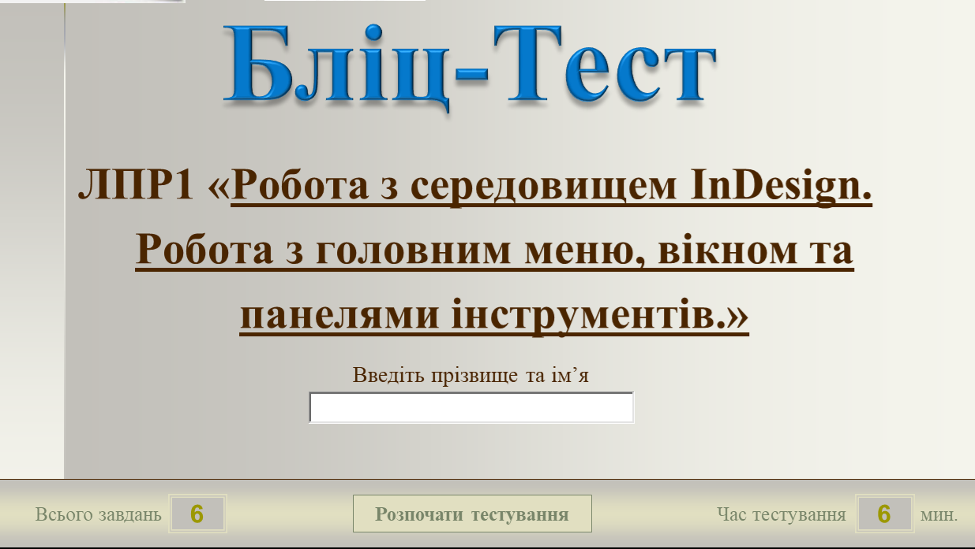
Fig. 7. A set of test blitz tests for fixing the theoretical material developed by MS Power Point
Advantage of such testing is to run it without installing special software and connecting to the Internet.
Also, to test the acquired knowledge, we used the didactic materials created with the Learning Apps service (Fig. 8), Web 2.0 service to support educational processes in various types of educational institutions. This is a constructor for the development of interactive tasks for various subject disciplines for use in lessons and in extracurricular work [6, p. 100].
Fig. 8. A set of interactive exercises of various types, developed by the Learning Services online services
The service contains a gallery of public interactive tasks, which is updated daily with new materials created by teachers from different countries.
The use of the software and hardware tools described above has made it possible to maximize the structuring and visualization of teaching materials and make the educational process interactive. We believe that this kind of presentation of educational material allows graduates of HEI not to drown in the flow of theoretical material, and it is easy to find answers to questions that arise during the study process of the basics of work in the Adobe InDesign CS5 environment.
3. RESEARCH RESULTS
Our research and their experimental verification confirm the effectiveness and innovation of the use of EOP in the process of training future educators in vocational training.
Thus, based on our research, we can state that electronic educational resources are new alternatives to traditional methods of organizing an educational process, methods and tools that provide the opportunity for individual learning, collective teaching and conducting online classes.
References:
[1] Provisions on electronic educational resources: Zat. by order of the Ministry of Education and Science, Youth and Sports of Ukraine from 1 October. 2012 № 1060; in ed. as of February 13 2019 Verkhovna Rada of Ukraine: [site]. URL: http://zakon4.rada.gov.ua/laws/show/z1695-12 - (reference date 25.02.16) (in Ukrainian).
[2] Spirin O.M. Criteria of external evaluation of the quality of information and communication technologies of training. Scientific journal of NP Drahomanov NPP. Series 2. Computer-Oriented Learning Systems: Sb. sciences Kiev, 2010. 9 (16). Pp. 80-85. (in Ukrainian).
[3] Rashevskaya NV Mobile Information and Communication Technologies for Higher Mathematics Students in Higher Technical Education Institutions: Diss. ... Candidate ped Sciences: 13.00.10. Kiev, 2011. 244 p. (in Ukrainian).
[4] Morse N.V., Glazunova O.G. Evaluation of the quality of electronic learning resources. Scientific notes of the Ternopil State Pedagogical University named after. V. Hnatyuk. Series: Pedagogy. 2008. No. 7. P. 37-52. (in Ukrainian).
[5] Matviychuk-Yudina O. V. Modern pedagogical requirements and norms of introduction of informatization of educational process in high school. Scientific notes of the Ternopil National Pedagogical University named after. V. Hnatyuk. Series: Pedagogy. Ternopil, 2011. S. 254-25 (in Ukrainian).
[6] Andreev A. A. Pedagogy of higher education. New course - Moscow: Moscow International Institute of Econometrics, Informatics, Finance and Law, 2002. - 264 s.il. (in Russian).

УДК 378.147.091.313:004

Роман Петрович Медведєв
Здобувач СВО «магістр»
спеціальності 015 «Професійна освіта (комп’ютерні технології)»
Віницького державного педагогічного університету імені Михайла Коцюбинського,
м. Вінниця, Україна
romadgan96@gmail.com
Людмила Станіславівна Шевченко
Доктор педагогічних наук, доцент, доцент кафедри інноваційних
та інформаційних технологій в освіті Віницького державного педагогічного університету
імені Михайла Коцюбинського,
м. Вінниця, Україна
lysi4801@gmail.com
ORCID ID 0000-0003-4991-4949
Володимир Олександрович Уманець
Кандидат педагогічних наук, доцент кафедри інноваційних
та інформаційних технологій в освіті, начальник інформаційно-обчислювального відділу
Віницького державного педагогічного університету імені Михайла Коцюбинського, м. Вінниця, Україна
umkavin@gmail.com
ORCID ID orcid.org/0000-0002-7237-4955

ЕЛЕКТРОННИЙ ОСВІТНІЙ РЕСУРС НАВЧАННЯ ОСНОВ КОМП’ЮТЕРНОЇ ВЕРСТКИ МАЙБУТНІХ ПЕДАГОГІВ ПРОФЕСІЙНОЇ ОСВІТИ

Анотація. У статті описано результати теоретико-експериментального дослідження проблеми розробки і використання комплексу електронних освітніх ресурсів навчання комп’ютерної верстки у процесі професійної підготовки майбутніх бакалаврів спеціальності 015.10 «Професійна освіта (комп’ютерні технології)».
У процесі нашого дослідження, нами було з’ясовано можливості використання електронних освітніх ресурсів в освітньому процесі ЗВО для підготовки майбутніх педагогів професійної освіти. Зокрема нами розроблено електронний освітній ресурс «Основи комп’ютерної верстки» в якому, відповідно до, структуровано необхідні навчальні матеріали та авторські методичні розробки для вивчення основ комп’ютерної верстки в програмному середовищі Adobe InDesign CS5.
Середовищем для створення описаного ЕОР стала популярна система керування вмістом сайту (CMS) Word Press, яка має відкритий вихідний код та поширюється під ліцензією GNU GPL.
Розроблений ЕОР містить комплекс авторських навчальних та методичних матеріалів, матеріалів для контролю рівня навчальних досягнень, що в сукупності дозволяють формувати у майбутніх педагогів професійного навчання теоретичні знання та практичні навички основ комп’ютерної верстки у програмному середовищі Adobe InDesign CS5.
Для цілеспрямованої реалізації концептуальних ідей дослідження розроблено авторську методику використання комплексу електронних освітніх ресурсів навчання комп’ютерної графіки майбутніх бакалаврів спеціальності 015.10 «Професійна освіта (комп’ютерні технології)». Методика передбачає надання практичних знань, умінь і навичок майбутнім бакалаврам професійної освіти з метою формування професійних компетентностей з навчальної дисципліни «Спеціальна інформатика» (модуль 3 «Основи комп’ютерної верстки в програмі Adobe In Design CS5»).Keywords: e-learning resource; computer layout; Adobe InDesign CS5; WordArt; Learning Apps; My Test X; future educators of professional training.
Ключові слова: електронний освітній ресурс, комп’ютерна верстка, Adobe InDesign CS5, WordArt, Learning Apps, My Test X, майбутні педагоги професійного навчання.

УДК 378.147.091.313:004

Роман Петрович Медведев
Соискатель СВО «магистр»
специальности 015 «Профессиональное образование (компьютерные технологии)»
Винницкий государственний педагогический университет имени Михаила Коцюбинского, м. Винница, Украина
romadgan96@gmail.com
Людмила Станиславовна Шевченко
Доктор педагогических наук, доцент, доцент кафедры инновационных
и информационных технологий в образовании Винницкий государственний педагогический университет имени Михаила Коцюбинского, м. Винница, Украина
lysi4801@gmail.com
ORCID ID 0000-0003-4991-4949

Владимир Александрович Уманец
Кандидат педагогических наук, доцент кафедры инновационных и информационных технологий в образовании, начальник информационно-вычислительного отдела Винницкий государственний педагогический университет имени Михаила Коцюбинского, м. Винница, Украина
umkavin@gmail.com
ORCID ID orcid.org/0000-0002-7237-4955

ЭЛЕКТРОННЫХ ОБРАЗОВАТЕЛЬНЫХ РЕСУРСОВ ОБУЧЕНИЕ ОСНОВАМ КОМПЬЮТЕРНОЙ ВЕРСТКИ БУДУЩИХ ПЕДАГОГОВ ПРОФЕССИОНАЛЬНОГО ОБРАЗОВАНИЯ

Аннотация. В статье описаны результаты теоретико-экспериментального исследования проблемы разработки и использования комплекса электронных образовательных ресурсов обучения компьютерной верстки в процессе профессиональной подготовки будущих бакалавров специальности 015.10 «Профессиональное образование (компьютерные технологии)».
В процессе нашего исследования, нами было выяснено возможности использования электронных образовательных ресурсов в образовательном процессе ЗВО для подготовки будущих педагогов профессионального образования. В частности нами разработан электронный образовательный ресурс «Основы компьютерной верстки», в котором, согласно, структурировано необходимые учебные материалы и авторские методические разработки для изучения основ компьютерной верстки в программной среде Adobe InDesign CS5.
Средой для создания описанного ЭОР стала популярна система управления содержимым сайта (CMS) Word Press, которая имеет открытый исходный код и распространяется под лицензией GNU GPL.
Разработанный ЭОР содержит комплекс авторских учебных и методических материалов, материалов для контроля уровня учебных достижений, в совокупности позволяют формировать у будущих педагогов профессионального обучения теоретические знания и практические навыки основ компьютерной верстки в программной среде Adobe InDesign CS5.
Для целенаправленной реализации концептуальных идей исследования разработана авторская методика использования комплекса электронных образовательных ресурсов обучения компьютерной графики будущих бакалавров специальности 015.10 «Профессиональное образование (компьютерные технологии)». Методика предусматривает предоставление практических знаний, умений и навыков будущим бакалаврам профессионального образования с целью формирования профессиональных компетенций по дисциплине «Специальная информатика» (модуль 3 «Основы компьютерной верстки в программе Adobe In Design CS5»). Keywords: e-learning resource; computer layout; Adobe InDesign CS5; WordArt; Learning Apps; My Test X; future educators of professional training.
Ключевые слова: электронный образовательный ресурс, компьютерная верстка, Adobe InDesign CS5, WordArt, Learning Apps, My Test X, будущие педагоги профессионального обучения.

